|  |  |
| --- | --- |
| Name: M NABEEL ZAIB | EE-272L Digital Systems Design |
| Reg. No.: 2023-EE-067 | Marks Obtained: ____________ |

**Lab Manual**

**EXPERIMENT 1**

|  |  |  |  |  |  |
| --- | --- | --- | --- | --- | --- |
| **DSD Lab Manual Evaluation Rubrics** | | | | | |
|  |  |  |  |  |  |
| **Assessment** | **Total Marks** | **Marks Obtained** | **0-30%** | **30-60%** | **70-100%** |
| Code Organization (CLO1) | 3 |  | No Proper Indentation and descriptive naming, no code organization.  Zero to Some understanding but not working | Proper Indentation or descriptive naming or code organization.  Mild to Complete understanding but not working | Proper Indentation and descriptive naming, code organization.  Complete understanding, and proper working |
| Simulation (CLO2) | 5 |  | Simulation not done or incorrect, without any understanding of waveforms | Working simulation with errors, don't cares's(x) and high impedance(z), partial understanding of waveforms | Working simulation without any errors, etc and complete understanding of waveforms |
| FPGA (CLO2) | 2 |  | Not implemented on FPGA and questions related to synthesis and implementation not answered. | Correctly Implemented on FPGA or questions related to synthesis and implementation answered. | Correctly Implemented on FPGA and questions related to synthesis and implementation answered. |

**TASK**

**Task 1**

When we apply 5V at terminal A , the terminal voltage across B is 1.94V and the led doesn’t glow

**Task 2**

When we apply 0V at terminal A, the terminal voltage across the B is 0V and led glow

**TASK 3**

Now we apply 1 kHz, 5V peak voltage square wave at terminal A using the signal generator . Input and output waveforms generated by oscilloscope are given below . Proporgation delays are

* High to low voltage : 1.60 mircoseconds
* Low to high voltage: 2.4 microseconds

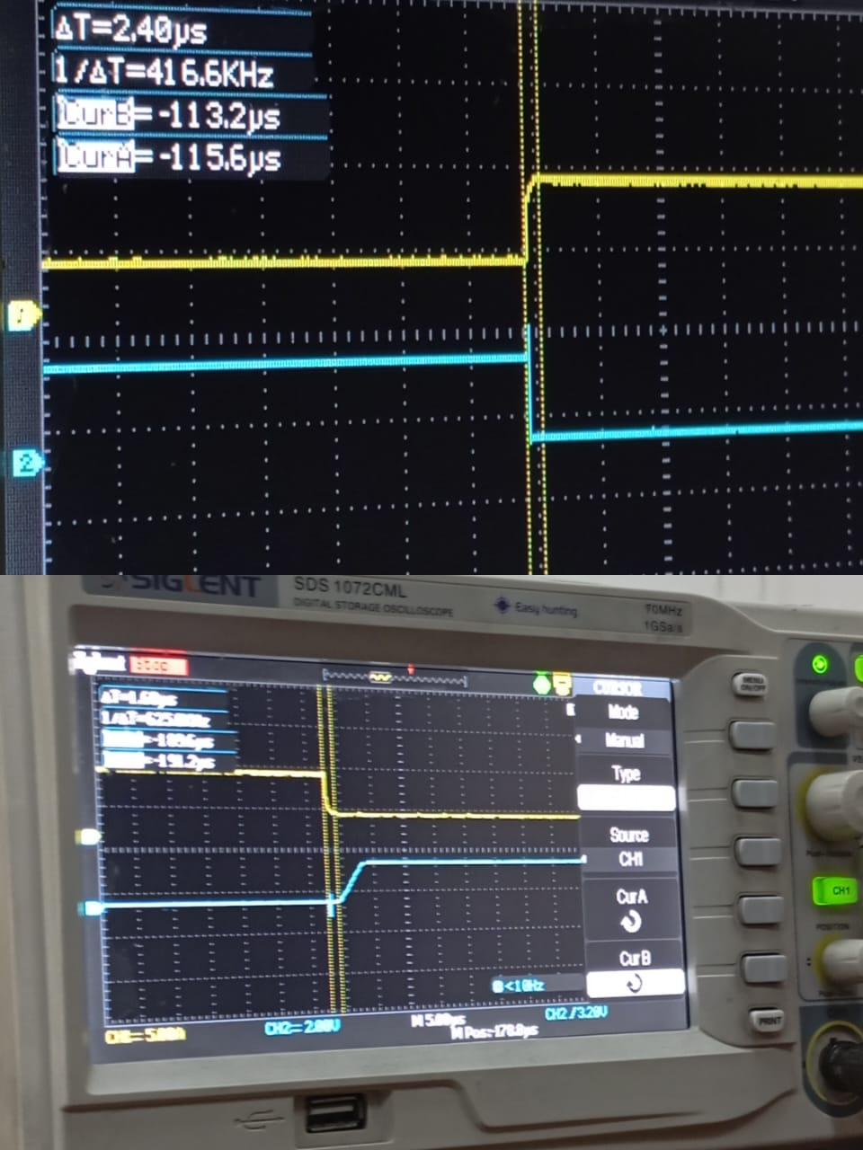

**Task4**

Now we apply 100kHz, 5V peak voltage square wave at terminal A using the signal generator . Input and output waveforms generated by oscilloscope are given below . Proporgation delays are

High to low voltage : 2.0 mircoseconds

Low to high voltage: 2.0 microseconds

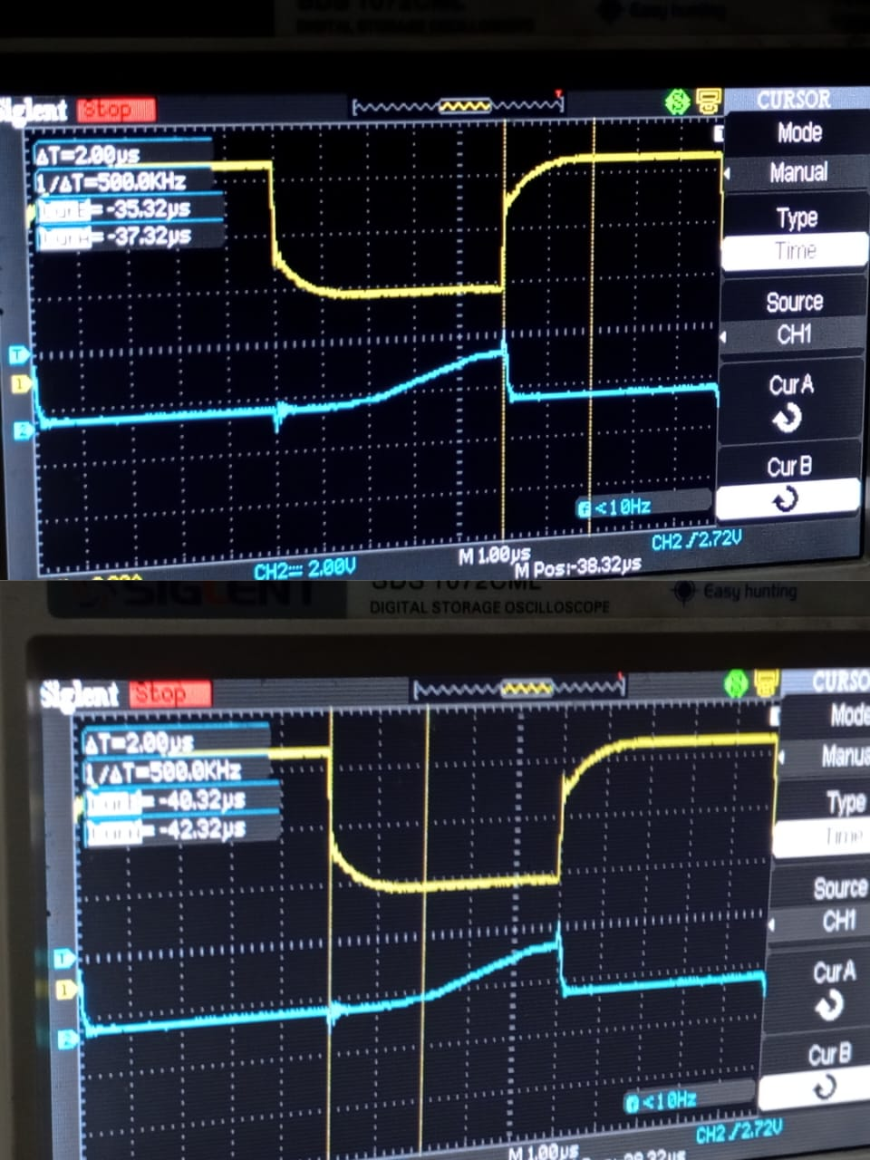

**Task 5**

Propagation delay is the time a transistor needs to switch between ON and OFF states, and it decreases as frequency increases.

* **At low frequency**, the input signal changes slowly, allowing the transistor to fully turn ON and OFF, ensuring proper switching.
* **At high frequency**, the signal changes too quickly, and the transistor may not get enough time to complete its transition, affecting its switching performance.